**Task 4. Use various data types, List, Tuples and Dictionary in python programming**

**Aim:**

        To use various data types, List, Tuples and Dictionary in python programming

1. **You are working on a Python project that requires you to manage and manipulate a list of numbers. Your task is to create a Python program that demonstrates the following list operations:**
2. **Add Elements**: Add elements to the list.
3. **Remove Elements**: Remove specific elements from the list.
4. **Sort Elements**: Sort the list in ascending and descending order.
5. **Find Minimum and Maximum**: Find the minimum and maximum elements in the list.
6. **Calculate Sum and Average**: Calculate the sum and average of the elements in the list.

**ALGORITHM**

1. Start
2. For adding elements to a list first create a list with name “list” and assign the values within [] brackets , inorder to add a new value use the function append().
3. For removing a specific element use “pop(index value)” or “remove(itemname)”.
4. For sorting the elements use “sorted(list)” function.
5. For finding minimum value use “min(list)” and for maximum use “max(list)”.
6. For sum use function “sum(list)” and for average use the formula “sum(list)/len(list)”
7. Print the output.
8. End.

**PROGRAM**

#Add Elements: Add elements to the list.

list=[10,20]

a=30

list.append(a)

print(list)

#Remove Elements: Remove specific elements from the list.

list.pop(1)#by index value

print(list)

list.remove(10)#by itemname

print(list)

#Sort Elements: Sort the list in ascending and descending order.

l=[5,8,9,15,30,89]

print(sorted(l))

#Find Minimum and Maximum: Find the minimum and maximum elements in thelist.

print("The minimum value is:",min(l))

print("The maximum value is:",max(l))

#Calculate Sum and Average

print("The sum is:",sum(l))

print("The average is :",((sum(l)/len(l))))

OUTPUT

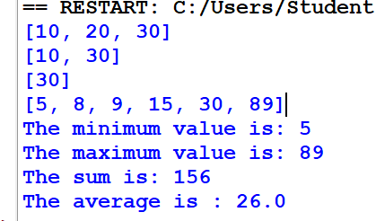

1. **You are tasked with creating a Python program that showcases operations on tuples. Tuples are immutable sequences, similar to lists but with the key difference that they cannot be changed after creation. Your program should illustrate the following tuple operations:**
2. **Create a Tuple**: Define a tuple with elements of different data types(10, 'hello', 3.14, 'world')
3. **Access Elements**: Access individual elements and slices of the tuple.
4. **Concatenate Tuples**: Combine two tuples to create a new tuple.
5. **Immutable Nature**: Attempt to modify elements of the tuple and handle the resulting error.

**ALGORITHM**

1. Start.
2. To create a tuple use “tuple_name=(values)”.
3. To access the elements of a tuple either use the index values ( tuple_name(index_value)) or the tuple slicing ( tuple_name[start:end]).
4. To concatenate tuples use the operator “+” (tuple1 “+” tuple2).
5. Try to modify the tuple elements by assigning the values directly like ; tuple(index)= new_value , will result in an error as it is immutable.
6. Print the output.
7. End.

**PROGRAM**

#Create a Tuple: Define a tuple with elements of different data types(10, 'hello', 3.14, 'world')

tuple=(10, 'hello', 3.14, 'world')

print(tuple)

#Access Elements: Access individual elements and slices of the tuple.

for i in tuple:

    print(i)

print(tuple[1:3])

print(tuple[:-1])

#Concatenate Tuples: Combine two tuples to create a new tuple.

t2=(5,0.5)

t3=tuple+t2

print(t3)

#Immutable Nature: Attempt to modify elements of the tuple and handle the resulting error.

tuple(3)="PI" #ERROR

**OUTPUT**

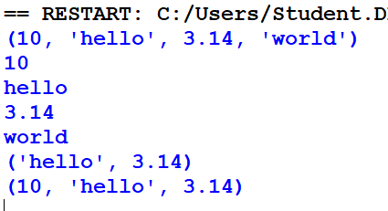

1. **You are tasked with creating a Python program that showcases operations on dictionaries. Dictionaries in Python are unordered collections of items. Each item is a pair consisting of a key and a value. Your program should illustrate the following dictionary operations:**
2. **Create a Dictionary**: Define a dictionary with key-value pairs of different data types.({'name': 'Alice', 'age': 30, 'city': 'New York'}
3. **Access Values**: Access values using keys.
4. **Modify Dictionary**: Update values, add new key-value pairs, and remove existing pairs.
5. **Iterate Over Dictionary**: Use loops to iterate over keys or values.

**Algorithm**

1. Start the program
2. Define a dictionary with key-value pairs of different data types.
3. Retrieve values from the dictionary using their corresponding keys.
4. Modify Dictionary
5. Iterate Over Dictionary
6. Stop the program.

**PROGRAM**

#Create a Dictionary: Define a dictionary with key-value pairs of different data types.({'name': 'Alice', 'age': 30, 'city': 'New York'}

dictionary={'name': 'Alice', 'age': 30, 'city': 'New York'}

print(dictionary)

#Access Values: Access values using keys.

print(dictionary['name'])

print(dictionary['age'])

#Modify Dictionary: Update values, add new key-value pairs, and remove existing pairs.

dictionary['name']= "James"

print(dictionary)

dictionary.pop('city')

print(dictionary)

#Iterate Over Dictionary: Use loops to iterate over keys or values.

for k in dictionary:

    print("KEY:",k)

print(dictionary.items())

**OUTPUT**

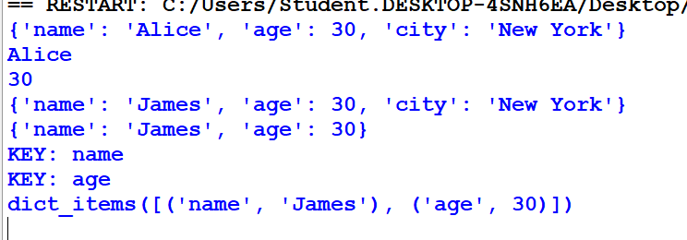

**RESULT**

     Thus, various data types, List, Tuples and Dictionary in python programming was used and verified successfully.